Candescent OIDC Feature Toolkit
User Guide
v1.0

Version History
Version | Date | Author(s) | Reviewed By | Remarks
0.1 | 25-Nov-2025 | Vithal Anpat / Vandita Verma | Pinkar Kumari / Saurabh Prasad | Initial draft version
0.2 | 09-Dec-2025 | Vandita Verma | Premal Shrivastava / Abhishek Anand | Updates after review by Candescent PO, QA
1.0 | 15-Dec-2025 | Vandita Verma | Premal Shrivastava / Abhishek Anand / Saurabh Prasad | New chapter added for Validator & Publisher feature

Table of Contents
Version History 2
Table of Contents 3
1. Introduction 5
2. How to Get the OIDC Toolkit 5
3. Setting Up the OIDC Toolkit 7
3.1 Docker Based Setup 7
Prerequisites 7
Setup Steps 7
Installation steps for Shell environment (Mac/Linux) 7
Installation steps for PowerShell environment (Windows) 10
3.2 Local Machine Native Setup 13
Prerequisites 13
Setup Steps 13
4. OIDC Toolkit Overview 16
4.1 Components 16
4.2 Initialization and Usage Flow Description 16
5. OIDC Endpoints and Parameters 18
5.1 Authorization Endpoint 18
Purpose 18
Example Request 18
Parameters 19
5.2 Token Endpoint 19
Purpose 19
Example Request 19
Success Response 20
6. OIDC Toolkit Execution Flow 21
Step 1 — User Opens the sample Web Application 21
Note: 22
Step 2 — Download the Metadata File 22
Step 3 — Download the JWKS File 23
Step 4 — Enter OIDC Inputs 23
Required Inputs (for both iframe and new tab modes): 23
Additional Inputs (only for iframe mode): 23
Iframe Permissions (only for iframe mode): 23
Submit the Form: 24
Note: 25
Step 5 — OIDC SSO Window Opens Up 25
Iframe Mode 25
New Tab Mode 25
Step 6 — Initiate OIDC Login 26
Note: 27
Step 7 — Decode ID Token 27
7. Validator and Publisher 30

1. Introduction
The OIDC Feature Toolkit allows developers from FI/Vendor organizations to simulate and validate the complete OpenID Connect (OIDC) Single Sign-On (SSO) flow, compatible with Candescent platform, in a local development environment. This Toolkit acts as a simulator to replicate the key functionalities of an OIDC Identity Provider, such as the authorization, token, and with JWKS configuration. Thus, it allows developers to verify during development, that their application’s OIDC integration works as expected, and is compatible with the Candescent platform.
The toolkit allows FI/Vendor developers to:
- Quickly set up sample back-end & front-end applications
- Generate client credentials and download metadata & JWKS files.
- Integrate their application with the Toolkit sample application and execute the OIDC flow
- Generate and validate sample ID Token to verify the user information

2. How to Get the OIDC Toolkit
Please visit the JFrog Artifactory to download the OpenID Connect (OIDC) Toolkit - JFrog Artifactory
If you do not have access to the JFrog Artifactory, follow below mentioned steps to request the access:
Step 1: Navigate to ServiceNow
- Go to General Service Request - Employee Center.
Step 2: Select Request Details
- Request Category: Business Application
- Request Sub-Category: JFrog Artifactory

Step 3: Fill in Short Description
- Example:
Requesting access to the JFrog Artifactory digitalbanking-rpm-snapshots repository to download oidc-sso-toolkit.zip.
Step 4: Fill in Description
- Example:
Need access to the following URLs for downloading toolkit zip files:
JFrog Artifactory

3. Setting Up the OIDC Toolkit
The OIDC Toolkit can be installed and setup using either of the two installation modes:
- Docker Based Setup
- Local Machine Native Setup

3.1 Docker Based Setup

Prerequisites
Before running the OIDC Toolkit using Docker, ensure the following is installed:
- Docker (latest stable version)
For Candescent employees: You can download Docker from the Self-Service Portal
For external users: Please download Docker from the official Docker website: https://www.docker.com/get-started

- Shell environment (Mac / Linux ) or PowerShell environment (Windows) to run setup scripts

Note: Local Node.js and npm installation are not required for Docker-based execution.

Setup Steps

Installation steps for Shell environment (Mac/Linux)
- Unzip the zip file containing the OIDC Toolkit, oidc-sso-toolkit.zip , inside any desire folder on the local machine

- Ensure Docker process is running in the background. If not, start Docker using Docker Desktop or any other mechanism

- Configure Frontend and Backend Ports (Optional):
By default the frontend application binds to port 8000, and the backend application binds to port 9000. However, if required, these ports can be changed to any other desired values.

Update the port numbers in /sample-web-app/config.json to new values for both frontend and backend, and restart the server to apply the updated ports.
- Navigate to the scripts folder within the unzipped toolkit folder and build the Docker image:
cd scripts
./shell/init.sh

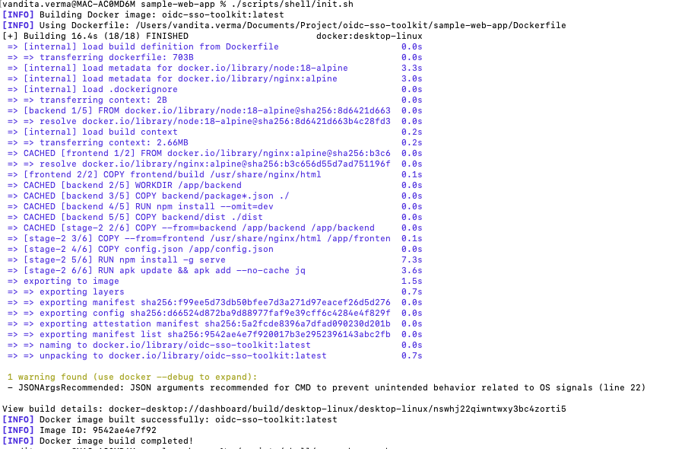
- Run the application container:
./shell/run-web-app.sh

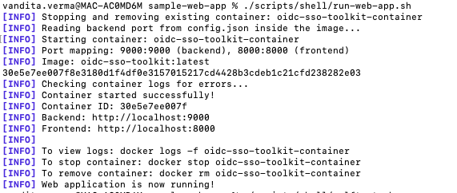

- Verify the health of the backend and frontend applications:
./shell/selftest.sh

Check for success response in the log, as shown below:

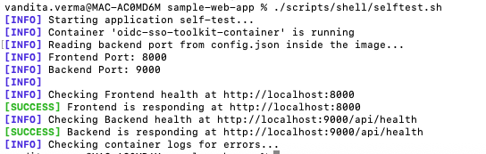

- Open frontend in browser: http://localhost:8000

Note: If the frontend port is modified in step 3, then open
http://localhost:<port>

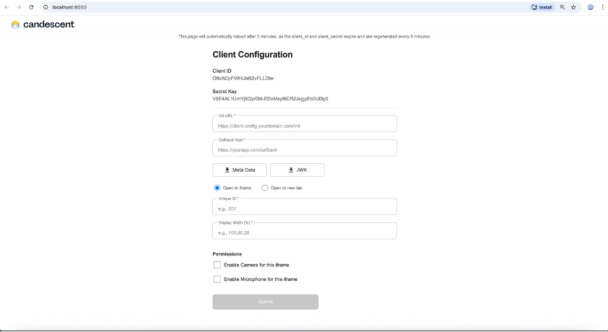

Installation steps for PowerShell environment (Windows)

- Unzip the zip file containing the OIDC Toolkit, oidc-sso-toolkit.zip , inside any desire folder on the local machine

- Ensure Docker process is running in the background. If not, start Docker using Docker Desktop or any other mechanism

- Configure Frontend and Backend Ports (Optional):
By default the frontend application binds to port 8000, and the backend application binds to port 9000. However, if required, these ports can be changed to any other desired values.

Update the port numbers in /sample-web-app/config.json to new values for both frontend and backend, and restart the server to apply the updated ports.

- Navigate to the scripts folder and build the Docker image:
cd scripts
./ps/init.ps1

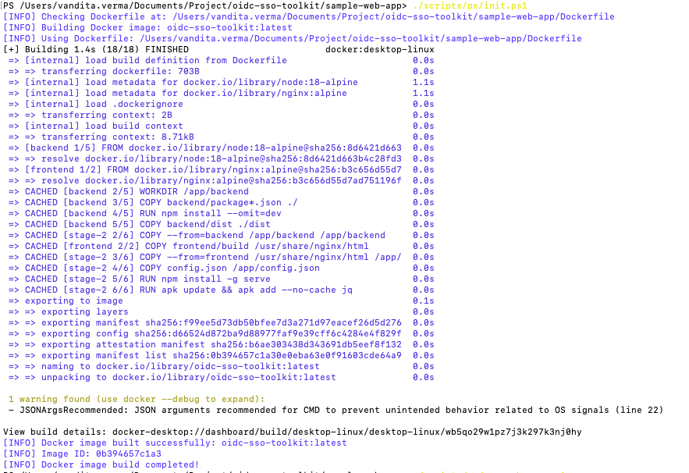

Note: If the above command triggers a security error
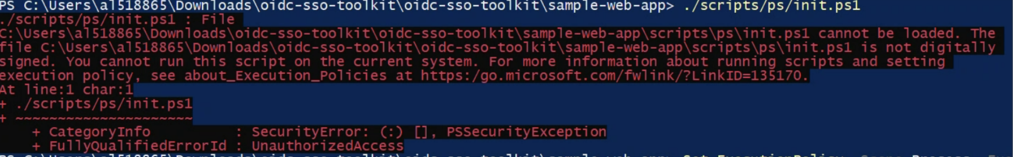
Solution: Bypass the security using the command provided below.

Set-ExecutionPolicy -Scope Process -ExecutionPolicy Bypass

- Run the application container:
./ps/run-web-app.ps1

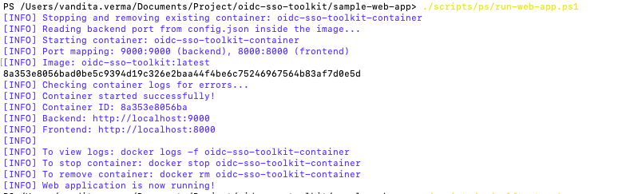

- Verify the health of the backend and frontend applications:
./ps/selftest.ps1

Check for success response in the log, as shown below:

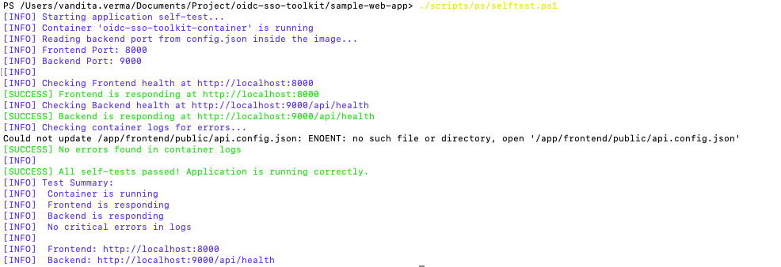

- Open frontend in browser: http://localhost:8000

Note: If the frontend port is modified in step 3, then open
http://localhost:<port>

3.2 Local Machine Native Setup

Prerequisites
Before running the toolkit locally, ensure the following are installed on the local machine:
- Node.js 22
- npm 8+
Note: Docker is not required for local native setup.

Setup Steps
Important: Make sure to setup and start backend server, before installing frontend server.
Backend Setup
- Navigate to backend folder within the unzipped toolkit and install dependencies by running the following commands:
cd sample-web-app/backend
npm install

2. Configure Backend Port (Optional):
By default the frontend application binds to port 8000, and the backend application binds to port 9000. However, if required, these ports can be changed to any other desired values.

Update the port numbers in /sample-web-app/config.json to new values for both frontend and backend, and restart the server to apply the updated ports.

3.Start backend server:
npm run start:prod
(the backend server will bind to the default port 9000)

4. Open the health check url for backend in browser: http://localhost:9000/api/health

Verify the server health, as indicated by status “ok” in the response.
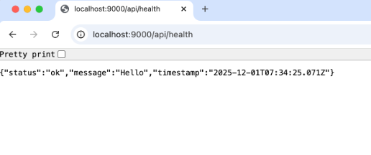
Note: If the backend port is modified in step 2, then open
http://localhost:<port>/api/health

Frontend Setup
- Navigate to frontend folder and install dependencies:
cd sample-web-app/frontend
npm install
npm install -g serve

2. Configure frontend Port (Optional):
By default the frontend application binds to port 8000, and the backend application binds to port 9000. However, if required, these ports can be changed to any other desired values.

Update the port numbers in /sample-web-app/config.json to new values for both frontend and backend, and restart the server to apply the updated ports.
Note: Both servers must run on different ports to work properly.

3. Start frontend:
serve -s build -l <PORT>

(where <PORT> is the same port as specified in config.json file)

4. Open frontend in browser: http://localhost:8000
(the frontend server will bind to the default port 8000)
Note: If the frontend port is modified in step 2, then open
http://localhost:<port>

4. OIDC Toolkit Overview
The OIDC Toolkit provides a complete local environment for testing and validating OpenID Connect (OIDC) Single Sign-On (SSO) flows. It simulates key components of Candescent platform OIDC flow and allows users to securely integrate, test, and validate authentication workflows in their local development environment.

4.1 Components
Frontend:
- Displays generated client credentials (client_id, client_secret, created_at).
- Allows downloading metadata (metadata.json) and JWKS files.
- Validates and decodes ID Tokens to securely display user information.
Backend:
- Generates client credentials with a short-lived expiry.
- Manages key pairs (RSA public/private keys).
- Signs ID Tokens using RSA.
- Exposes JWKS for token verification.

4.2 Initialization and Usage Flow Description
Step 0 – Initialization:
- Client Credentials Generation
- On loading the Home Page, the frontend automatically calls the backend API.
- The backend generates client credentials and returns them to the frontend.
- Credentials are displayed on the home page. The page refreshes automatically after 15 minutes to fetch new credentials.
- Metadata Download
- Clicking the Metadata button to download metadata.json.
- The file contains redirect URIs, endpoints, scopes, and other OIDC configuration details.
- JWKS Download
- Clicking the JWKS button downloads the JSON Web Key Set, containing RSA public key parameters (n and e) for token verification.
- A success message confirms the download.

Step 1 – Token Validation and User Info:
- After authentication, the frontend shows the ID Token payload.
- The ID Token can be decoded on the website jwt.io
- Validate the following fields in the ID Token to ensure integrity and correctness: issued at (iat), expiry (exp), issuer, subject (sub), audience (aud), email, birthday, given name, family name, phone number, preferred username.

5. OIDC Endpoints and Parameters

5.1 Authorization Endpoint

Purpose
Starts the user authentication flow and returns an authorization code.

Example Request
Step 1 — Get Client ID
http://localhost:9000/api/client
This returns the client_id. Use this value in the next step.
Step 2 — Initiate Authorization Request
http://localhost:9000/api/auth/authorize?
client_id={{client_id}}
&response_type=code
&scope=openid
&redirect_uri=https://yourapp.com/callback
&state=jt4ozs
Note: If the backend port is modified in toolkit setup step, then open
http://localhost:<port>

Parameters
Parameter | Purpose
client_id | dummy credentials generated to uniquely identity the FI
response_type | Should be "code" for Authorization Code Flow
scope | Must include "openid"
redirect_uri | can be any url which user will be redirected after auth code generation
state | Random anti-CSRF string

5.2 Token Endpoint

Purpose
Exchange authorization code for tokens:
- Access Token
- ID Token
- (Optional) Refresh Token

Example Request
POST http://localhost:9000/api/auth/token
Headers:
Authorization: Basic <base64(client_id:client_secret)>
Content-Type: application/x-www-form-urlencoded
Body:
grant_type=authorization_code
&code=SplxlOBeZQQYbYS6WxSbIA
&redirect_uri=https%3A%2F%2Fyourapp.com%2Fcallback
Note: If the backend port is modified in toolkit setup step, then open
http://localhost:<port>

Success Response
{
"access_token": "eyJ…",
"token_type": "Bearer",
"expires_in": 3600,
"id_token": "eyJhbGciOiJSUzI1NiIsImtpZCI6…"
}

6. OIDC Toolkit Execution Flow

Step 1 — User Opens the sample Web Application
- When the user visits http://localhost:8000 the homepage, the frontend initiates a request to fetch fresh client credentials for the session.
Note: If the frontend port is modified in toolkit setup step, then open
http://localhost:<port>

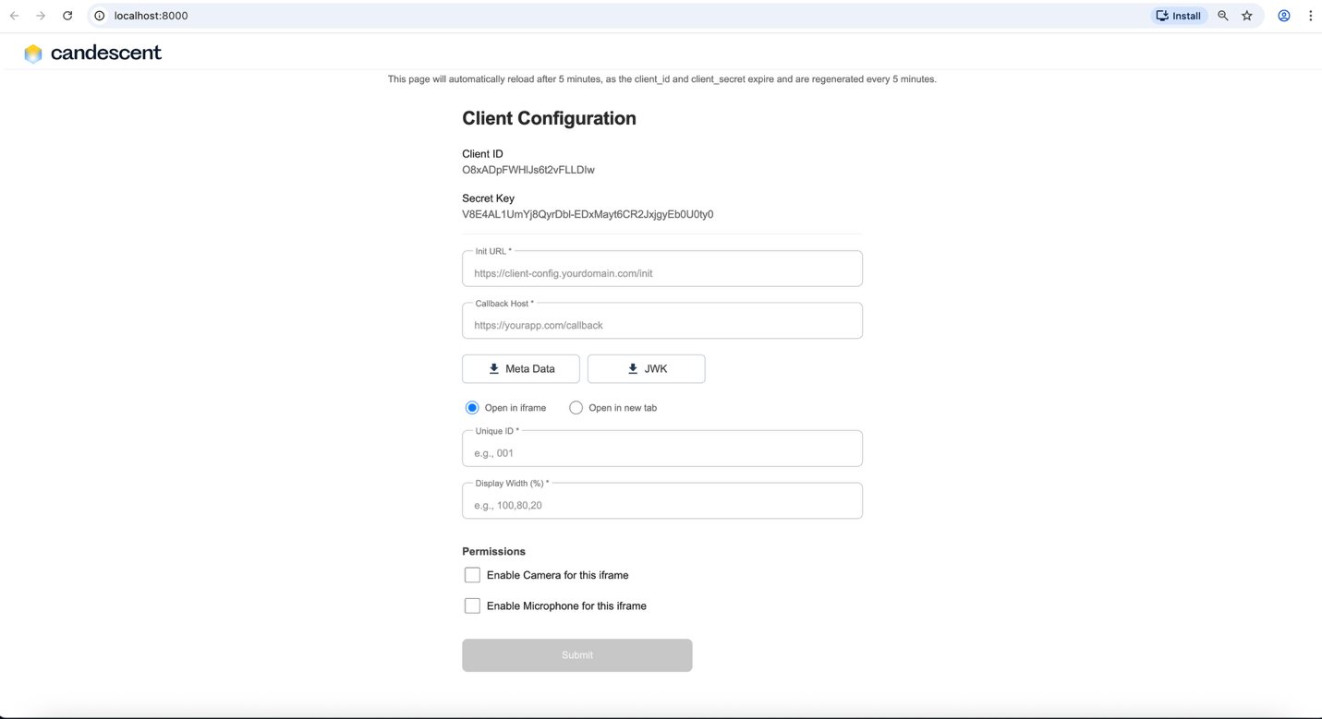

Note:
Backend Generates Client Credentials
- The backend generates:
  - client_id
  - client_secret
- Credentials are valid for 15 minutes.
- These are returned to the front end.

Frontend Displays Credentials
- The frontend shows:
  - Client ID
  - Client Secret
- The UI informs the user that the credentials will expire in 15 minutes.
- After expiry, the page automatically refreshes to fetch a new set of credentials.

Step 2 — Download the Metadata File
Click the “Meta Data” button:
- A metadata.json file is downloaded to the user’s system.
- The UI shows a confirmation message.
- The metadata file contains information such as:
  - Issuer
  - Authorization endpoint
  - Token endpoint
  - JWKS URI
  - Supported scopes
  - Supported response types
  - Supported subject types
  - Supported id token signing alg values
  - Supported token endpoint auth methods
  - Supported claims
Note: Metadata file is a static file for simulation purposes.

Step 3 — Download the JWKS File
Click the “JWK” button:
- A jwks.json file is downloaded to the user’s system.
- The UI shows a success message.
- This JWKS file contains public keys used for:
  - Validating ID Token signatures later in this feature.
  - Verifying token integrity
Note: JWKS file is a static file for simulation purposes.

Step 4 — Enter OIDC Inputs
Enter the required OIDC input parameters:

Required Inputs (for both iframe and new tab modes):
- Init URL
- Callback URL

Additional Inputs (only for iframe mode):
- Unique ID – identifies the iframe session
- Display Width (%) – controls the width of the iframe

Iframe Permissions (only for iframe mode):
- Enable Camera for this iframe – allows camera access
- Enable Microphone for this iframe – allows microphone access
Note: These fields are not required when the user chooses Open in New Tab.

Submit the Form:
- After entering the necessary details, click the Submit.
- The frontend prepares the OIDC Authorization URL using the client credentials and user inputs.
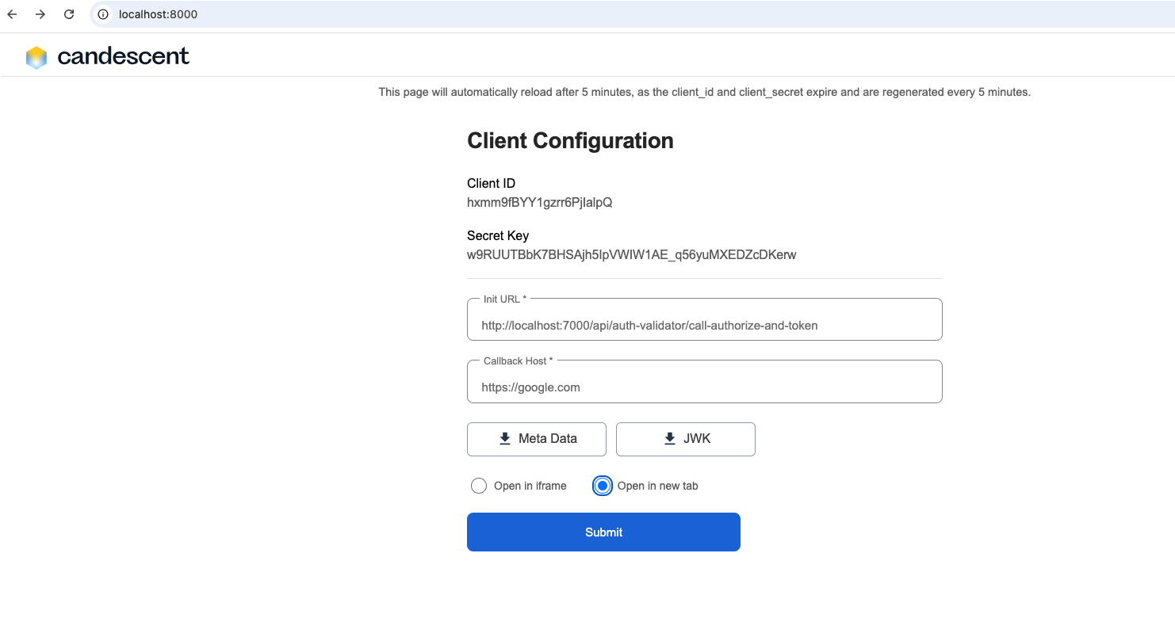

Note:
Frontend Constructs the OIDC Authorization URL
- The URL includes:
  - Client ID
  - Init URL
  - Callback URL
  - state and nonce values
  - Unique ID (only for iframe)
- This URL is ready to start the OIDC flow.

Step 5 — OIDC SSO Window Opens Up
Depending on the user’s selection:

Iframe Mode
- The authorization URL opens in an embedded iframe
- Unique ID, Display Width, and camera/microphone permissions are applied

New Tab Mode
- The URL opens in a separate browser tab
- iframe-specific fields are ignored
The user sees the “Start OIDC SSO” button.
Notes: Unique ID, Display Width, and camera/microphone permissions apply only for iframe mode.
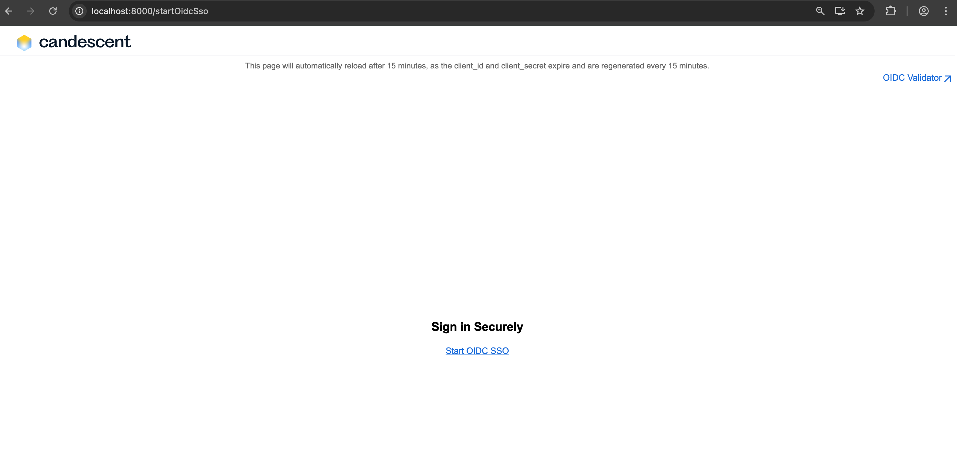

Step 6 — Initiate OIDC Login
- click Start OIDC SSO link
- Frontend redirects the user to the init page
- The frontend shows the ID Token to the user
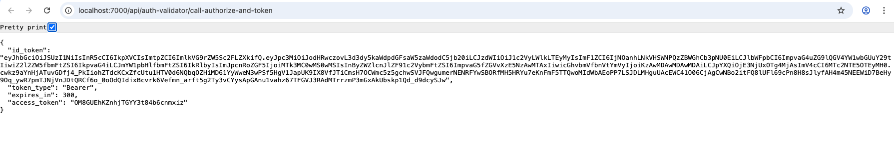

Note:
Backend Exchanges Authorization Code for Tokens
- The frontend sends the authorization code to the backend
- The backend:
  - Exchanges the code for an ID Token with the candescent toolkit.
  - Uses its private key to sign the ID Token
Backend Returns ID Token Payload
- Backend sends the ID Token payload back to the frontend
- Payload contains user claims, roles, and other OIDC information

Step 7 — Decode ID Token
- Obtain the ID Token
After the OIDC flow completes, you’ll have an ID Token
2. Go to JWT.io
Open https://jwt.io in your browser.
3. Paste the Token
In the “Encoded” section, paste the entire ID Token.
4. View Decoded Payload
- The site will automatically decode the token into Header, Payload, and Signature sections.
- The Payload contains user claims like sub, name, email, roles, etc.
5. Verify Signature (Optional)
- Open the Pre-Downloaded JWK File.
- Extract Key Values and Copy the values of "e" (exponent) and "n" (modulus) from the JWK file.
- Concatenate the Values of "e" and "n" into a single string as required for RSA public key representation.
- Paste the Public Key in the “Verify Signature” section of https://jwt.io, add the concatenated key.
- Once the key is added,https://jwt.io will indicate Signature Verified. 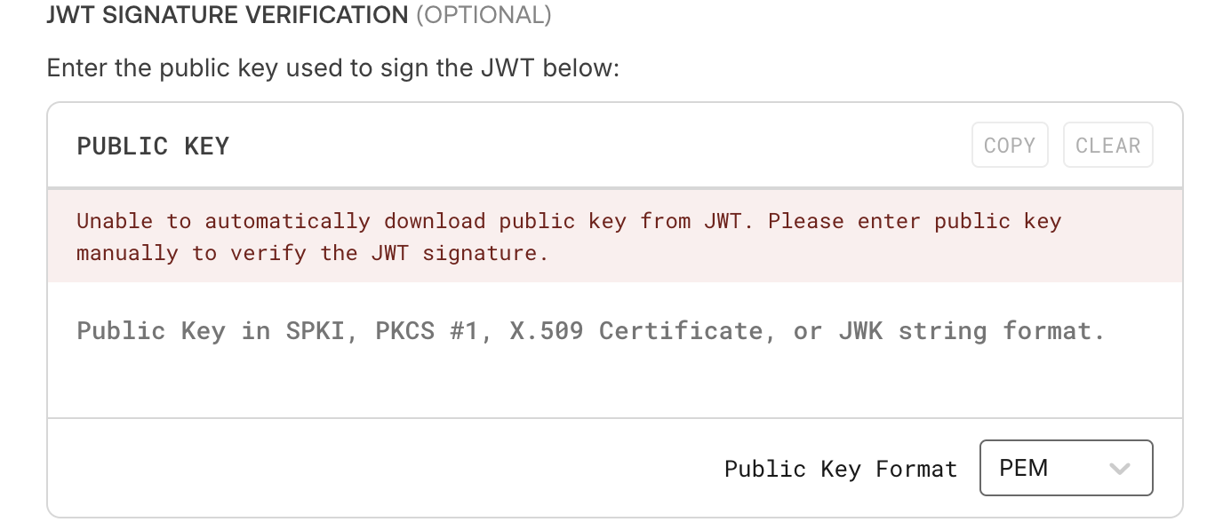
6. Check Expiry and Claims
Validate the following fields in the ID Token to ensure integrity and correctness:
exp — Expiry time
iss — Issuer
aud — Audience
iat — Issued at
sub — Subject (unique user identifier)
email — User’s email address
birthday — Date of birth
given_name — First name
family_name — Last name
phone_number — Contact number
preferred_username — Username
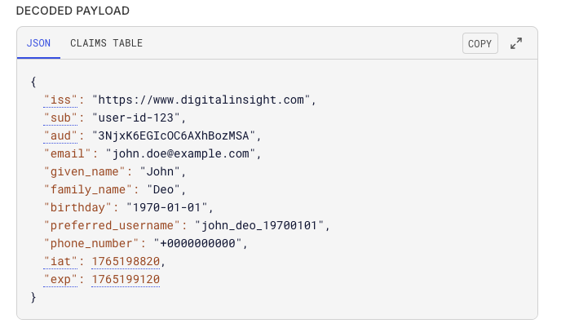

7. Validator and Publisher

Step 1:
In the Start OIDC SSO page, a link to the OIDC Validator will be displayed in the top right corner. Click on the OIDC Validator link.

Step 2:
The validator page will open. Click on the Run Validator button.
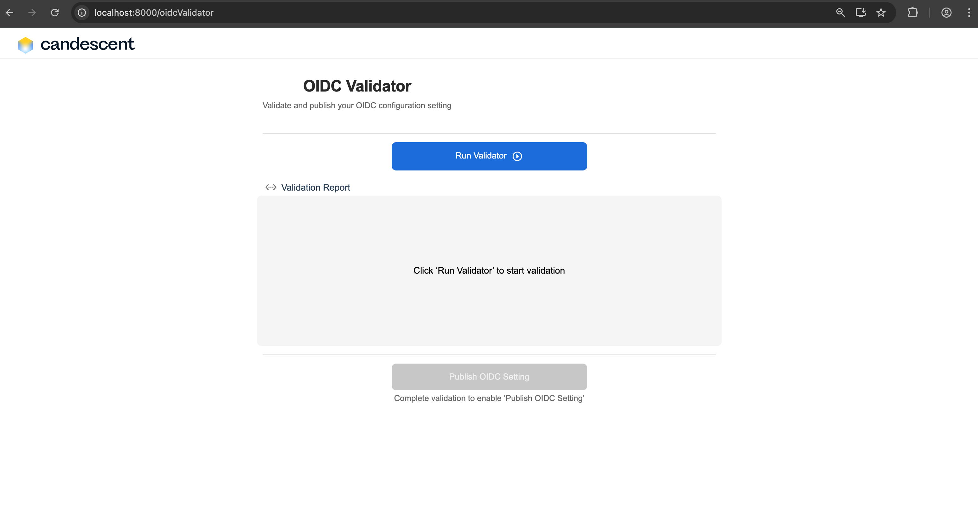

Step 3:
All the test cases will begin executing, and the corresponding validation reports will be displayed.
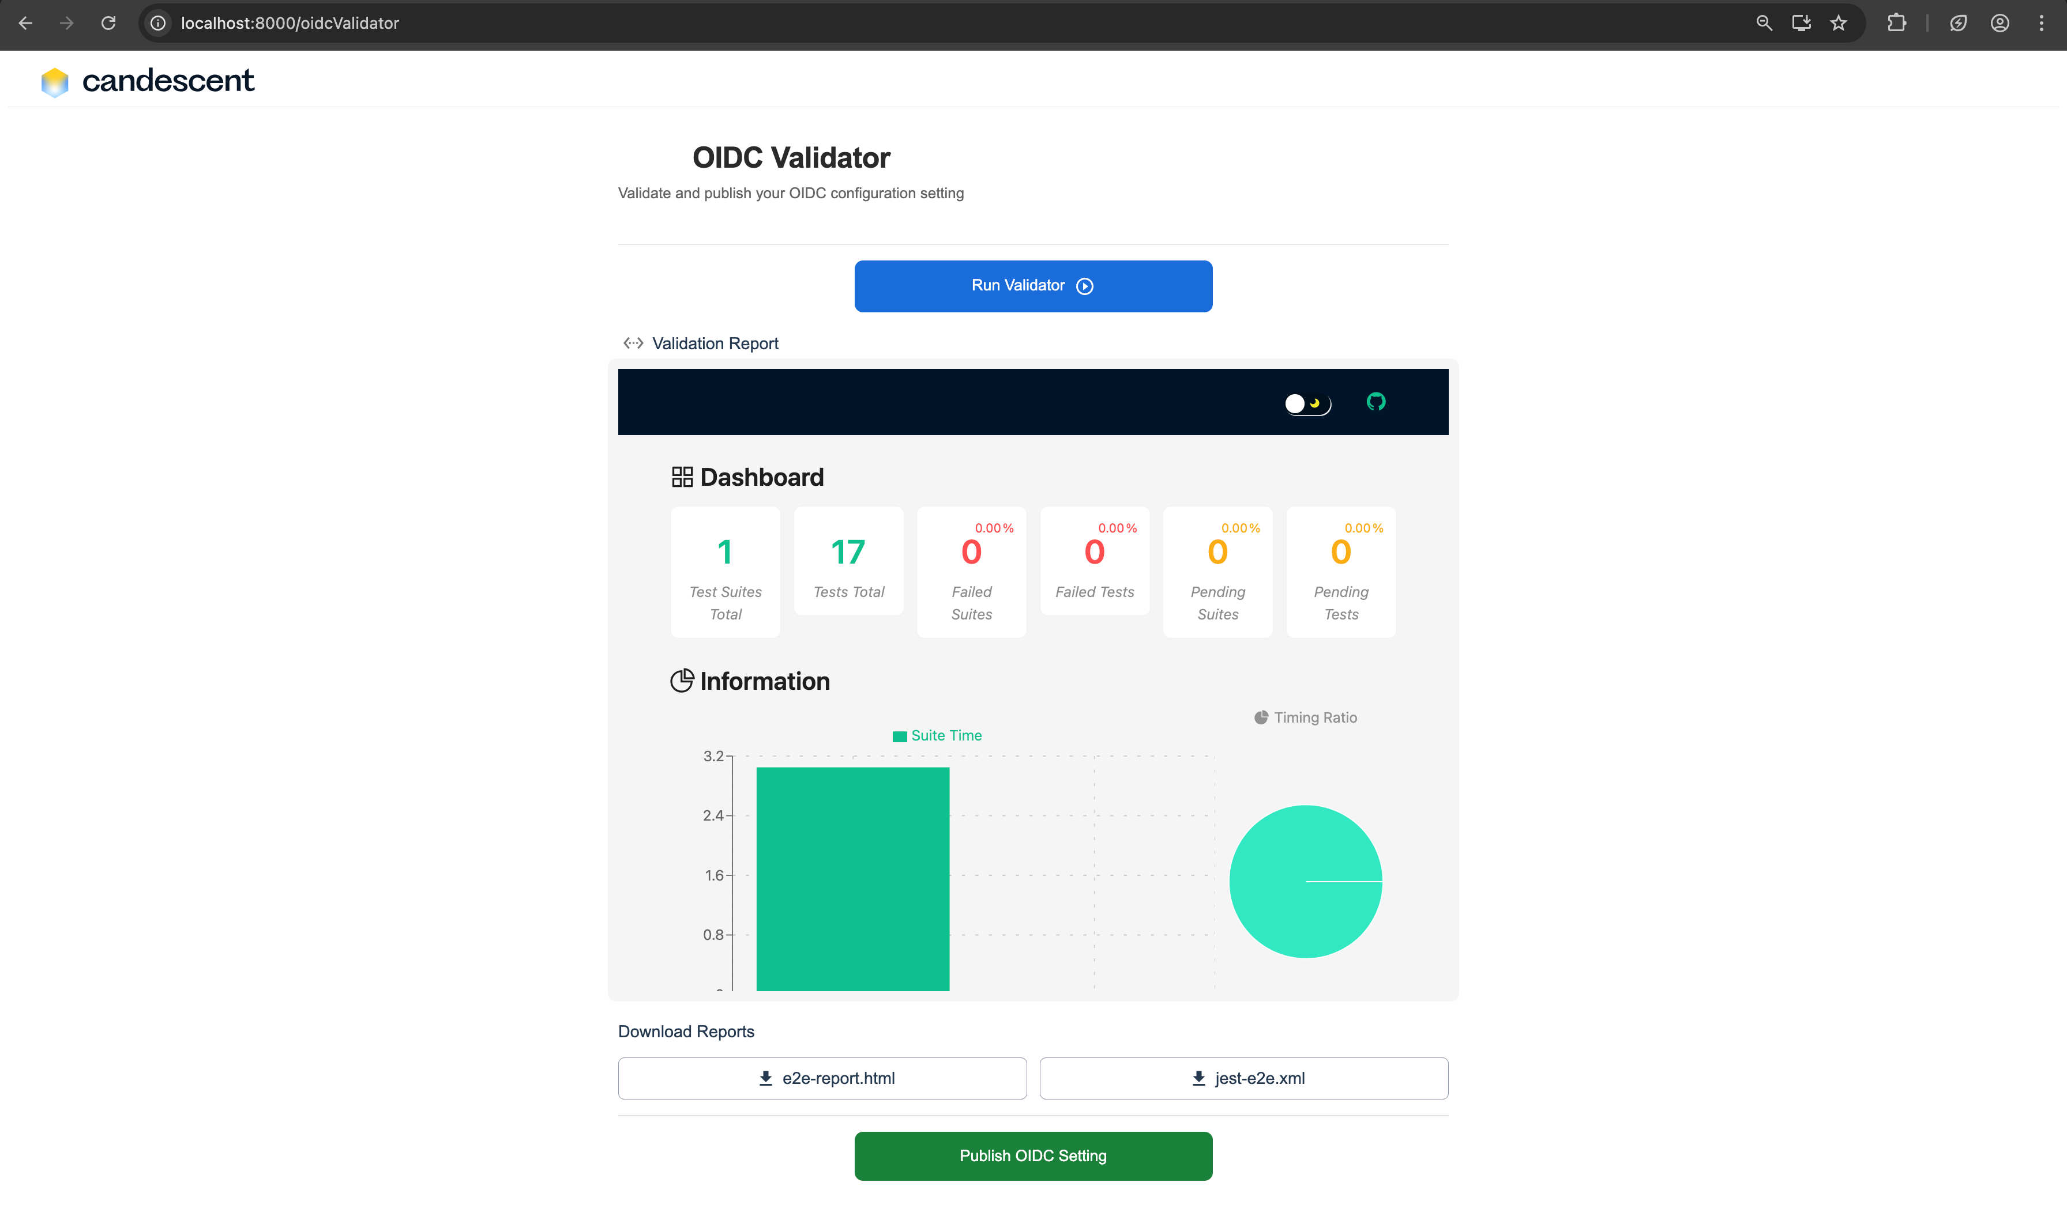
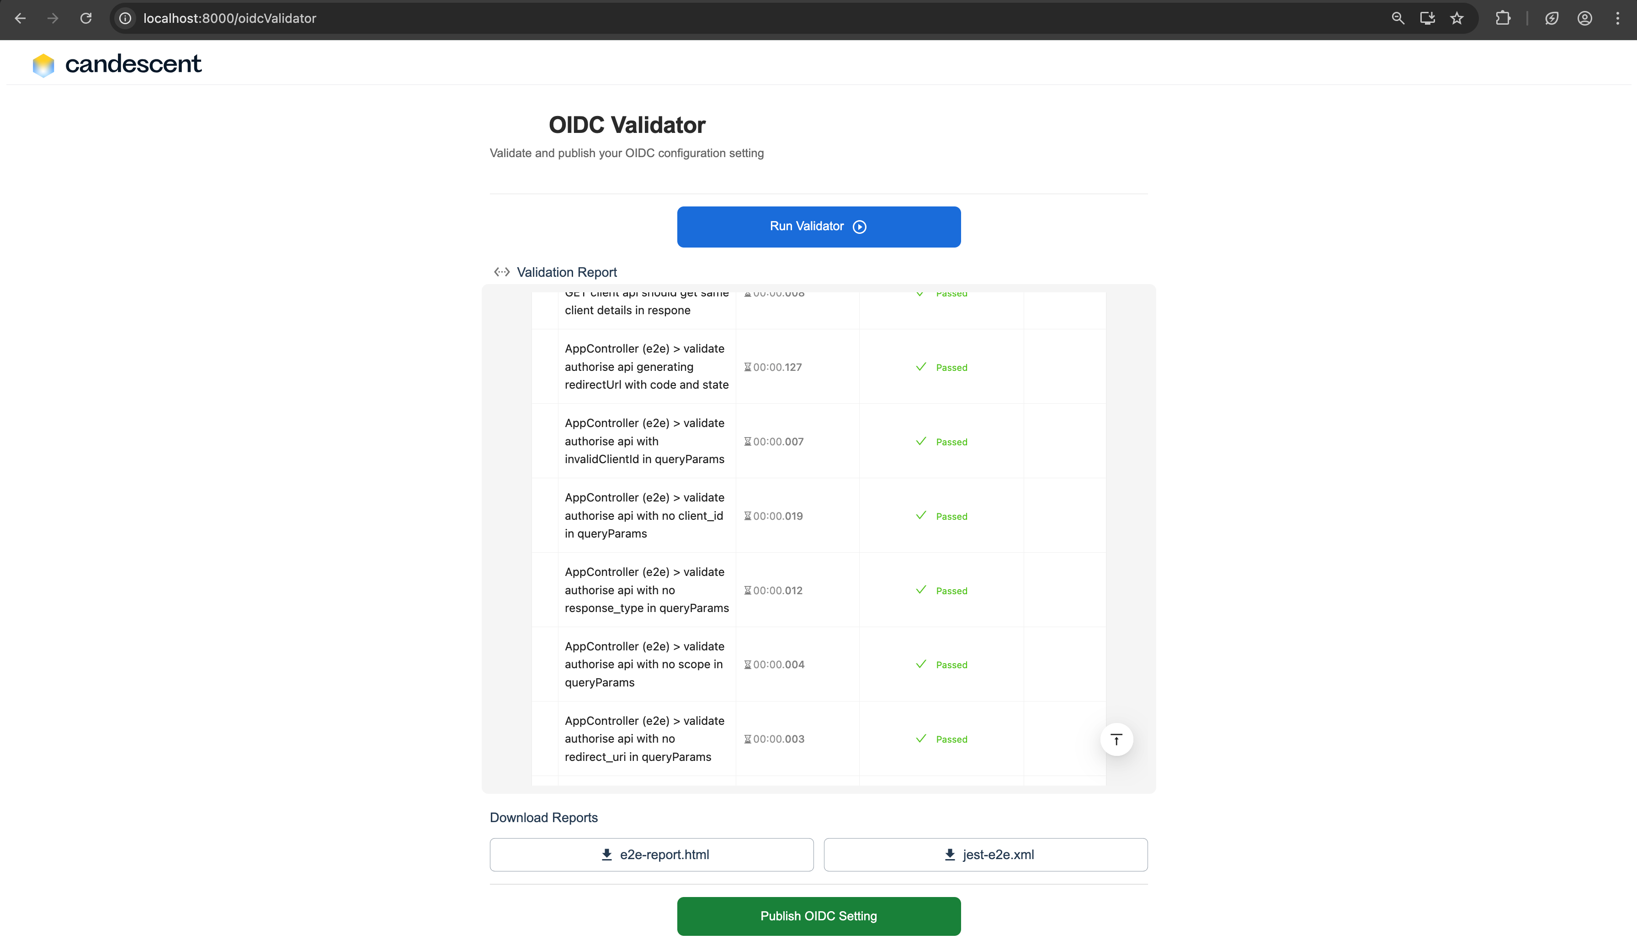

Step 4:
After the test case execution is complete, two additional downloadable test reports will appear:
- e2e-report.html
Click on e2e-report.html button to download. After downloading open the html file, to see the report as bellow:
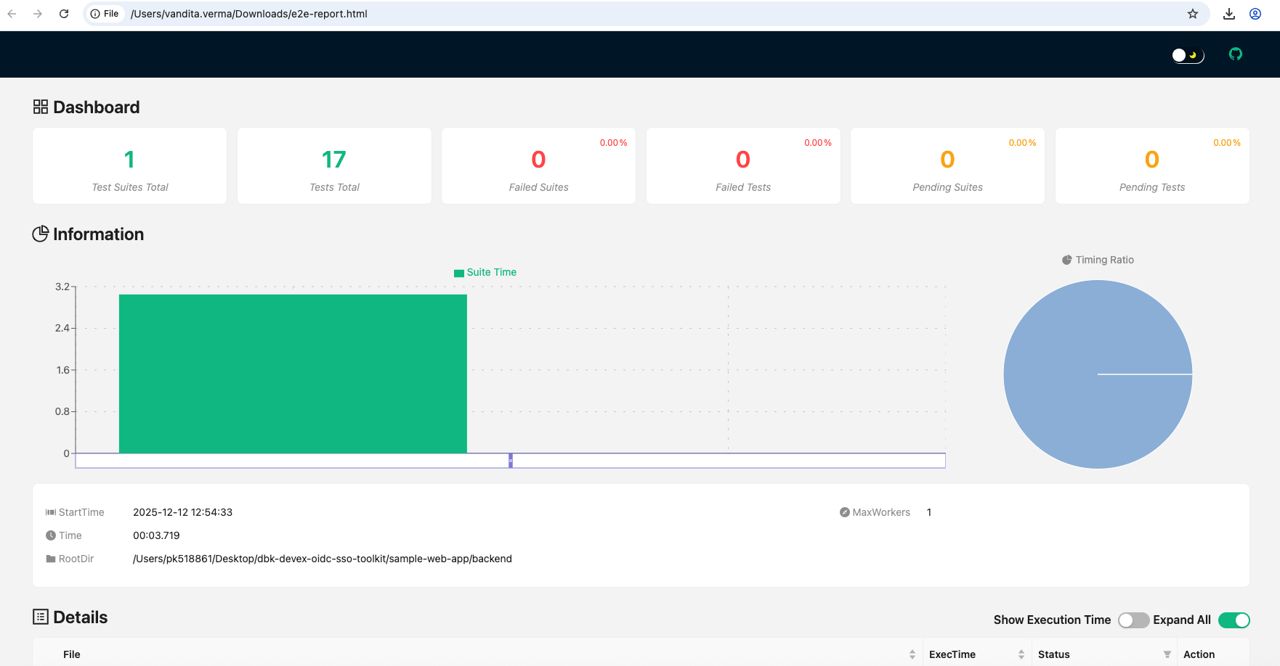
- jest-e2e.xml
Click on jest-e2e.xml button to download it. After downloading open the xml file, to see the report as bellow:
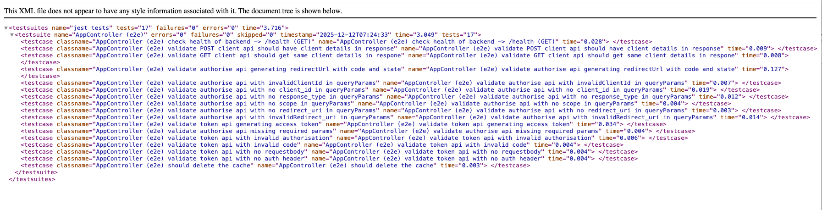

Step 5:
The Publish OIDC Setting button will be enabled. Click on the OIDC Setting button, a file named oidcConfig.json will be downloaded. Inside oidcConfig.json file, you will be able to view the following details:
- frontendPort
- backendPort
- initUrl
- callbackHost
